

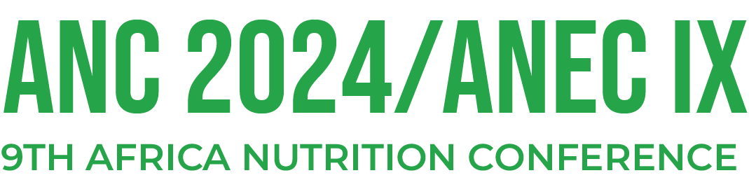

**Date: 7-11 October 2024**

**Venue: University of Cape Coast – North Campus**

**Cape Coast, Ghana**

African Nutrition Society & Ghana Academy of Nutrition and Dietetics,  
P.O. Box K18, Korle Bu,  
Accra, Ghana.

**Guidelines for Symposium/seminars/workshop organization**

ANEC Meetings typically encourage research groups, programs and organizations who wish to present their work as **‘Special or Satellite Symposia’, ‘Seminars’ or ‘training workshops’**. However in line with set standards for the conference, all such symposia must reflect the objectives of the conference and be relevant to the theme. Furthermore, special symposia should be intellectually focused and sound and devoid of any company marketing or promotional presentations which lack scientific evidence and / or are likely to bring the name of the African Nutrition Society into disrepute. Presentations at special symposia should also be publishable in the proceedings of the conference. Therefore it is expected that relevant abstracts will be submitted for presentations which will be subject to review by the Scientific Committee.

For all groups/organizations wishing to present special symposia, please follow the following guidelines and submit a brief **(Maximum 2-page**) summary information / Concept Note about your planned symposium.

|  |  |
| --- | --- |
| Title of Symposium / seminar / workshop |  |
| Summary/abstract/synopsis of Symposium/seminar/workshop |  |
| Speakers/facilitators/ moderators |  |
| Preference: (pre-conference; post-conference or during the conference e.g. lunch time, or parallel session etc.) |  |
| Time allocation requested (Duration) |  |
| Expected number and type of audience. |  |
| Brief information about your Group/Organization |  |

Kindly complete and provide the following information to the ANEC IX Scientific Committee.

Prof. Paul Amuna

Chair, Scientific Committee

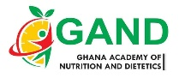****

**Organizers**

**www.anc.ansnet.org**